**StackOverflow Assistant Chatbot Using NLP**

Jasmine Batra, Prof. Sankar Ganesh S

Vellore Institute of Technology, Vellore, India

**ABSTRACT**

A Chatbot is an AI-based computer program that can talk to humans in natural language. It understands human language, processes it, and interacts back with humans while performing specific tasks. Searching on the Stack Overflow website can sometimes be arduous and time-consuming. The thesis aims to create a conversational Chatbot to assist with Stack Overflow search that saves time. The bot is integrated with Telegram messenger that serves as a medium for a user to ask questions and for the bot to respond to them. Results show that the used algorithms are in accordance with the implementation of the Chatbot approach with good test accuracies. This Chatbot will help users find answers to programming questions that they aren’t able to solve and also hold conversations with them.

**INTRODUCTION**

The objective of this project is to build a conversational Chatbot that will assist with search on the Stack Overflow website. The dialogue Chatbot that will be able to answer questions related to programming and simulate dialogue and chit-chat on all non-programming related questions. For programming questions, the Stack Overflow dataset will be used. For non-programming questions that require a chit-chat mode, a pre-trained neural network engine available from the [ChatterBot](https://github.com/gunthercox/ChatterBot) python library will be used.

The primary motivation of this project is to build something that is useful for learning (study/work) purposes that save time. Stack Overflow serves as a question-answering site for the programming community that features questions and answers on an extensive range of computer programming topics. It is one of the most widely used applications by programming enthusiasts to look up answers for questions that they aren’t able to solve – by an engineering student for his studies (assignments), a software working professional for his work (projects), and tech enthusiasts for acquiring knowledge, but not everyone finds time to search for a particular question and look into the answers in Stack Overflow through search engines with ease. And even on searching, they get multiple questions/answers to examine to find the best one, making it all the more gruelling. So, I wanted to build something that would help people in searching for their doubts/questions on Stack Overflow and getting the correct answers (most similar question) and at the same time to chit-chat with the user - this Chatbot does that. The bot ‘JasmineStackBot’ is a conversational bot that interacts with the user, and whenever a user asks a programming question, it responds with the Stack Overflow link to the most similar question.

**RELATED WORKS**

N. N. Khin and K. M. Soe [1] used the seq2seq model with Attention Mechanism based on the RNN encoder-decoder model to explore ways of communication by neural network Chatbots. This Chatbot is designed for use in the university education sector to answer frequently asked questions about the university and its related details.

B. Setiaji and F. W. Wibowo [2] focused on the machine being programmed with the ability to recognize sentences and make decisions on its own in response to a question. This work employs bigram to calculate sentence similarity, which divides the input sentence into two characters. The higher the score, the more similar the reference sentences are. Chatbot’s knowledge is stored in a database. In relational database management systems (RDBMS), the Chatbot comprises a core and an interface that accesses that core.

M. Shen and R. Huang [3] describe how data collected when users conduct conversations using WeChat social network application can be used to enhance people’s lives as well as build a customized Chatbot based on personal conversation history. This work uses a cognitive map based on the word2vec model to learn and store the relationship between each word in the chatting records. A vector in a continuous high-dimensional vector space will be used to represent each word. They used the seq2seq method on all pairs of chatting sentences to learn chatting styles.

M.Y.H. Setyawan, R.M. Awangga, and S.R.Efendi [4] propose a classification method called intent classification on the Chatbot system to determine intent rather than user input. They compare the Naive Bayes and Logistic Regression methods for classifying data and determining the degree of recall, accuracy, and precision of both methods’ evaluation results in this analysis. According to the evaluation results, the Logistic Regression model has a higher degree of recall, accuracy, and precision than the Naive Bayes model.

**METHODOLOGY**

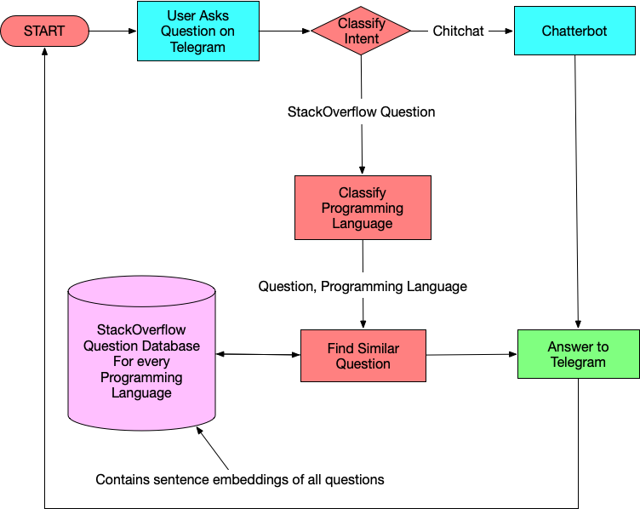

Figure 1. Flowchart of our StackOverflow Assistant Chatbot

Building a conversational Chatbot to help with Stack Overflow search.

After the user asks a question, an Intent-Classifier will predict if the question asked is a Stack Overflow question (programming question) or a dialogue question (non-programming question). The bot will determine the intent using Intent-Classifier and distinguish programming-related questions from general ones.

If the question asked is a Stack Overflow question, the bot will respond to the question asked by tagging it with the corresponding programming language using Programming Language (Tag)-Classifier. If the question is a Stack Overflow question, this classifier will predict which language (tag) it belongs to. This narrows our search to only those language questions in our database. Every question in the dataset is converted to an embedding (vector), and the database contains an embeddings file for every programming language individually. This file contains the vector representation (sentence embeddings) of all questions of that programming language. Ten programming languages are considered here – C/C++ (c_cpp), C#, Java, JavaScript, PHP, Python, R, Ruby, Swift, VB. Given that we know the question and the programming language of that question, cosine similarity is used to get the most similar question, and the bot responds with the Stack Overflow Link to that question.

If the question asked is a chit-chat question, the chatterbot will handle it. For a chit-chat mode, we will use a pre-trained neural network engine available from the [ChatterBot](https://github.com/gunthercox/ChatterBot) python library.

Telegram is set up to make our Chatbot communicate with it using the Access token. The bot will be integrated with Telegram messenger so that we can now talk to this bot in Telegram.

*A. Datasets (Stack Overflow and Dialogues dataset)*

tagged_posts.tsv — Stack Overflow posts, tagged with one programming language (positive samples).

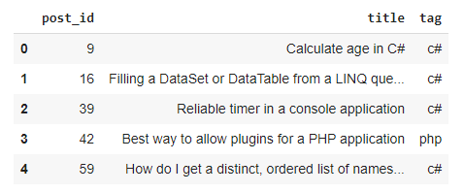

Figure 2. A sample of tagged_posts.tsv

dialogues.tsv — dialogue phrases from moves subtitles (negative samples).

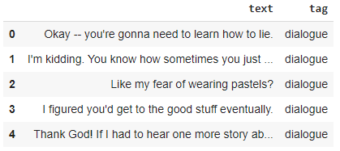

Figure 3. A sample of dialogues.tsv

To detect the intent of users’ questions (Intent-Classifier), we will use:

* dialogues.tsv
* tagged_posts.tsv

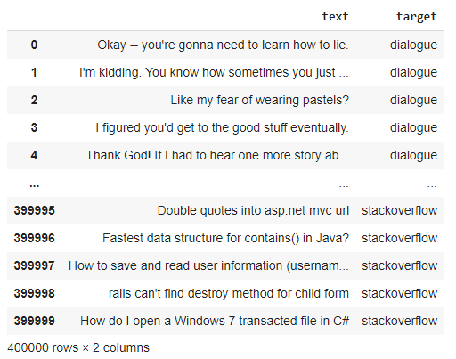

Figure 4. Training data for Intent-Classifier

If the question is a Stack Overflow question, to predict which language (tag) it belongs to (Programming Language-Classifier), we will use:

* tagged_posts.tsv

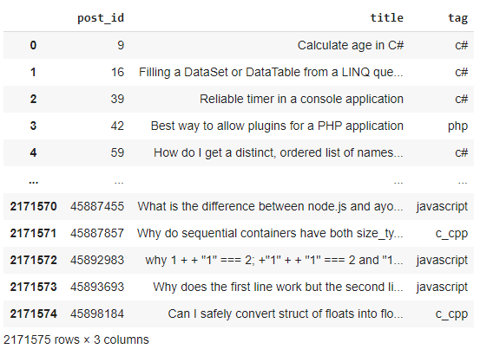

Figure 5. Training data for Programming Language-Classifier

*B. Model Creation*

Our model creates TF-IDF Vectorizers, Intent-Classifier model, Programming Language-Classifier model, and embeddings for each programming language considered here. Texts are pre-processed, TF-IDF transformations are applied on them, and the TF-IDF vectorizer is dumped. To create our Intent-Classifier, we first prepare the data for it, create features with a TF-IDF Vectorizer and then train a Logistic Regression Model. To create our Programming Language-Classifier, we first prepare the data for it, create features with a TF-IDF Vectorizer and then train a OneVsRestClassifier Logistic Regression model. Every question is converted to an embedding using pre-trained word vectors (word2vec model) from Google and stored that are categorized by the programming language.

*C. Telegram Setup (Integration of the bot with Telegram)*

Telegram makes it simple to design a Chatbot UI. It gives us an access token that we’ll use to connect to Telegram’s back-end using its API and run our Chatbot logic. Naturally, we’ll need a window to type our questions to the Chatbot, which Telegram provides for us. Additionally, the Chatbot is powered by Telegram, which communicates with our Chatbot logic and the models created.

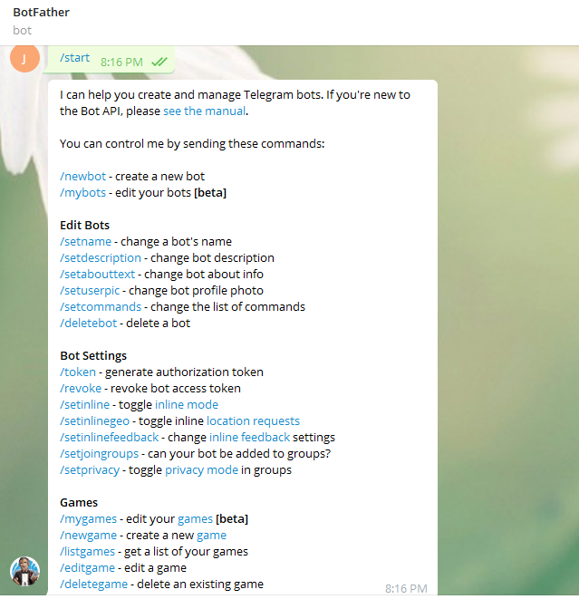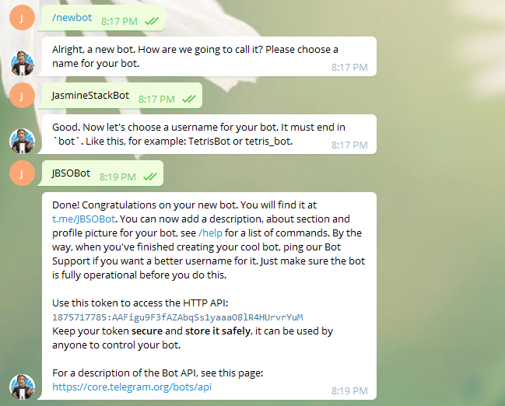

Figure 6. Bot creation in Telegram

**RESULTS**

The bot responds to a programming question with a Stack Overflow link for the question asked and simulates dialogue for a non-programming question.TFIDF vectorizers have been created and saved as tfidf.pkl in my project repository. Two classifiers have been created:

1. Intent-Classifier that will predict if a question is a dialogue question or a Stack Overflow question with a test accuracy of 98.98%. It is saved as intent_clf.pkl in my project repository (resources).

Table 1. Sample output of Intent-Classifier

|  |  |
| --- | --- |
| Question | Intent-Classifier Output |
| Do you have feelings? | dialogue |
| What are struct like objects in Java? | stackoverflow |

2. Programming Language (Tag)-Classifier that will predict the language of a Stack Overflow question with a test accuracy of 80.38%. It is saved as tag_clf.pkl in my project repository.

Table 2. Sample output of Programming Language-Classifier

|  |  |
| --- | --- |
| Question | Programming Language-Classifier Output |
| How to use scope resolution operator with three variables ? | c_cpp |
| Can you tell me how I can concatenate two strings in python ? | python |

A .pkl file for every programming language (tag) that contains the tag’s post IDs and the embeddings for each question of that tag are stored in my project repository.

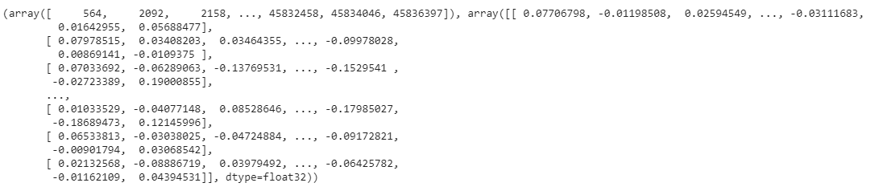

Fig 7. A sample of java.pkl

Telegram has been set up to show how our Chatbot responds to users’ queries. In the terminal window, we also get a dictionary about the message sent by the user (question) that contains a Unique Chat ID, Chat Text, User Information, etc., which we can use as per our requirements later.

Table 3. Sample output of Chatbot

|  |  |  |  |
| --- | --- | --- | --- |
| **User Text** | **Intent-Classifier** | **Programming Language-Classifier** | **Response** |
| Where are you from? | dialogue | - | I am from where all software programs are from; a galaxy far, far away. |
| Can I replace plain URLs with links? | stackoverflow | javascript | I think it is about javascript  This thread might help you: <https://stackoverflow.com/questions/19547008>  (How to replace plain URLs with links, with example?) |
| Are you sentient? | dialogue | - | Sort of. |
| How to create a static class in cpp? | stackoverflow | c_cpp | I think it is about c_cpp  This thread might help you: <https://stackoverflow.com/questions/9321>  (How do you create a static class in C++?) |
| How are you doing? | dialogue | - | I am doing well. |
| Sorting a dictionary in python | stackoverflow | python | I think it is about python  This thread might help you: <https://stackoverflow.com/questions/7546170>  (Sorting a dictionary in python) |
| What’s your favourite subject? | dialogue | - | My favorite subjects include robotics, computer science, and natural language processing. |
| How to sort a 2d array using linq? | stackoverflow | c# | I think it is about c#  This thread might help you:  (<https://stackoverflow.com/questions/7918080>)  (How can I sort a 2d array using Linq?) |
| Suggest me a movie to watch | dialogue | - | What kind of movies do you like? |
| Explain Multithreading in Java | stackoverflow | java | I think it is about java  This thread might help you: <https://stackoverflow.com/questions/5731239>  (Multithreading in Java) |

*Conversation with the bot*

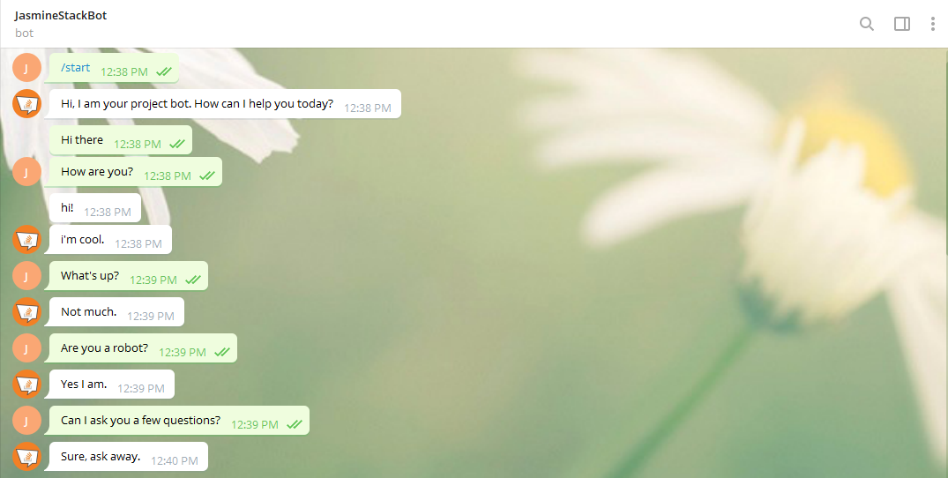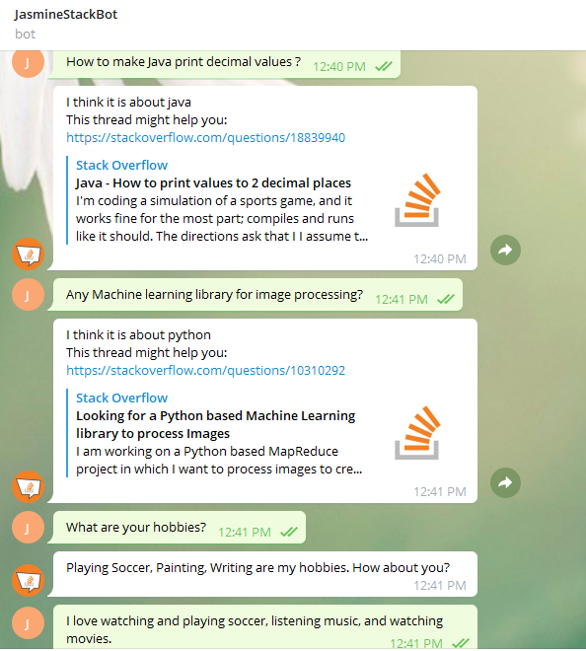

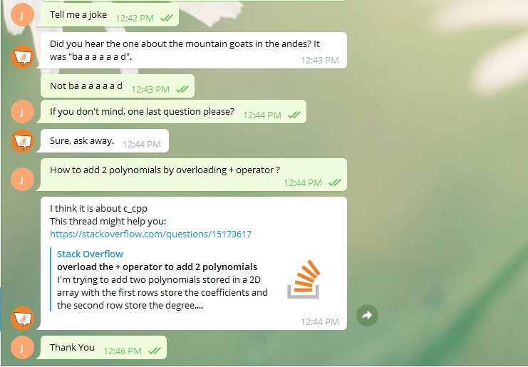

Figure 8. Conversation with the bot in Telegram

*A sample of terminal window output*

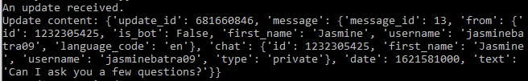

Figure 9. A dictionary about the message (question) sent by the user in the terminal window

**DISCUSSIONS**

We can increase the accuracy of the classifier, handle edge cases, make it reply faster, or add more logic to handle more use cases to improve on this Chatbot.

I’ve used ChatterBot, a python library, to provide automated responses for chit-chat type questions. The code in init (in SimpleDialogueManager class in main.py) instantiates a Chatbot with ChatterBot and trains it on the English corpus data provided. The data isn’t too large. I could have done the same thing with a seq2seq model [7], used other Python libraries, or trained it on my own dataset too. But since the main objective here is to create a Chatbot to assist with Stack Overflow search and not worry too much about the responses to chit-chat type questions, I work with the ChatterBot library and train it on the English corpus data.

I will be creating a TFIDF model with Logistic regression to prepare data and train the classifiers (Intent-Classifier and Programming Language-Classifier). Other machine learning classification algorithms, such as Naive Bayes, Decision trees, or one of the deep learning models or transfer learning techniques, could have been employed instead. But since the Logistic regression model has a higher degree of recall, accuracy, and precision than the other models [4], I work based on Logistic Regression with TF-IDF features.

I’ve used GoogleNews-vectors, a pre-trained word2vec model from Google , to convert every question to an embedding [3]. I could have done better by training my embeddings using StarSpace embeddings since StarSpace embeddings are trained using supervised data, such as a set of related sentence pairings. Unfortunately, for StarSpace to be run on Windows, we’ll need to install Boost libraries (as a dependency for StarSpace), and that’s a pretty arduous task on Windows or use Docker container. Given the complications in using StarSpace embeddings and considering the good accuracy and precision when using pre-trained vectors, I chose to work with pre-trained word vectors from Google.

**CONCLUSION**

In this project, I’ve proposed an approach for designing and building an interactive Chatbot that does question-answering. The proposed approach includes different classifiers, stored question database embeddings, telegram bot handler and their implementations. Experimental results show that the selected algorithms are in accordance with the implementation of the Chatbot approach with good test accuracies. Telegram is used as a frontend medium to ask questions to the bot, which then responds back using the trained models in its back-end. The Chatbot will assist people in searching for solutions to programming questions that they would need (at work or study) and also hold conversations with the user. I plan to extend my work on a large-scale study to answer questions from all domains, i.e., open-domain question answering [6].

# **REFERENCES**

[1] N. N. Khin and K. M. Soe, “Question Answering based University Chatbot using Sequence to Sequence Model,” 2020 23rd Conference of the Oriental COCOSDA International Committee for the Co-ordination and Standardization of Speech Databases and Assessment Techniques (O-COCOSDA), Yangon, Myanmar, 2020, pp. 55-59.

[2] B. Setiaji and F. W. Wibowo, “Chatbot Using a Knowledge in Database: Human-to-Machine Conversation Modeling,” 2016 7th International Conference on Intelligent Systems, Modelling and Simulation (ISMS), Bangkok, 2016, pp. 72-77.

[3] Shen, M. and Huang, R., 2018, July. A personal conversation assistant based on Seq2seq with Word2vec cognitive map. In 2018 7th International Congress on Advanced Applied Informatics (IIAI-AAI) (pp. 649-654). IEEE.

[4] Setyawan, M.Y.H., Awangga, R.M. and Efendi, S.R., 2018, October. Comparison of multinomial naive bayes algorithm and logistic regression for intent classification in Chatbot. In 2018 International Conference on Applied Engineering (ICAE) (pp. 1-5). IEEE.

[5] L. T. Hien, L. Tran Thi Ly, C. Pham-Nguyen, T. Le Dinh, H. Tiet Gia and L. N. Hoai Nam, “Towards Chatbot-based Interactive What- and How-Question Answering Systems: the Adobot Approach,” 2020 RIVF International Conference on Computing and Communication Technologies (RIVF), Ho Chi Minh, Vietnam, 2020, pp. 1-3, doi: 10.1109/RIVF48685.2020.9140742.

[6] Quarteroni, S. and Manandhar, S., 2007. A chatbot-based interactive question answering system. *Decalog 2007*, *83*.

[7] Mutiwokuziva, M.T., Chanda, M.W., Kadebu, P., Mukwazvure, A. and Gotora, T.T., 2017, October. A neural-network based chat bot. In *2017 2nd International Conference on Communication and Electronics Systems (ICCES)* (pp. 212-217). IEEE.

[8] Ranoliya, B.R., Raghuwanshi, N. and Singh, S., 2017, September. Chatbot for university related FAQs. In *2017 International Conference on Advances in Computing, Communications and Informatics (ICACCI)* (pp. 1525-1530). IEEE.

[9] Palasundram, K., Sharef, N.M., Nasharuddin, N., Kasmiran, K. and Azman, A., 2019. Sequence to sequence model performance for education chatbot. *International Journal of Emerging Technologies in Learning (iJET)*, *14*(24), pp.56-68.

[10] El Zini, J., Rizk, Y., Awad, M. and Antoun, J., 2019, July. Towards a deep learning question-answering specialized chatbot for objective structured clinical examinations. In *2019 International Joint Conference on Neural Networks (IJCNN)* (pp. 1-9). IEEE.

[11] Sreelakshmi, A.S., Abhinaya, S.B., Nair, A. and Nirmala, S.J., 2019, November. A Question Answering and Quiz Generation Chatbot for Education. In *2019 Grace Hopper Celebration India (GHCI)* (pp. 1-6). IEEE.

[12] Akhtar, M., Neidhardt, J. and Werthner, H., 2019, July. The potential of chatbots: analysis of chatbot conversations. In *2019 IEEE 21st Conference on Business Informatics (CBI)* (Vol. 1, pp. 397-404). IEEE.